Questionnaire for DSM2 Sediment Transport Model Technical Advisory Committee

January 13, 2010

What features are important to you for the Sediment Transport Model and its application to the Delta?

Do you know of any data sets or Delta sediment transport studies that you think that the model development team should investigate?

Is there anything else that you would like us to know and/or consider when developing STM?

Name and contact info (optional):

In your opinion, which of the following best depicts sediment distributions in the Delta?

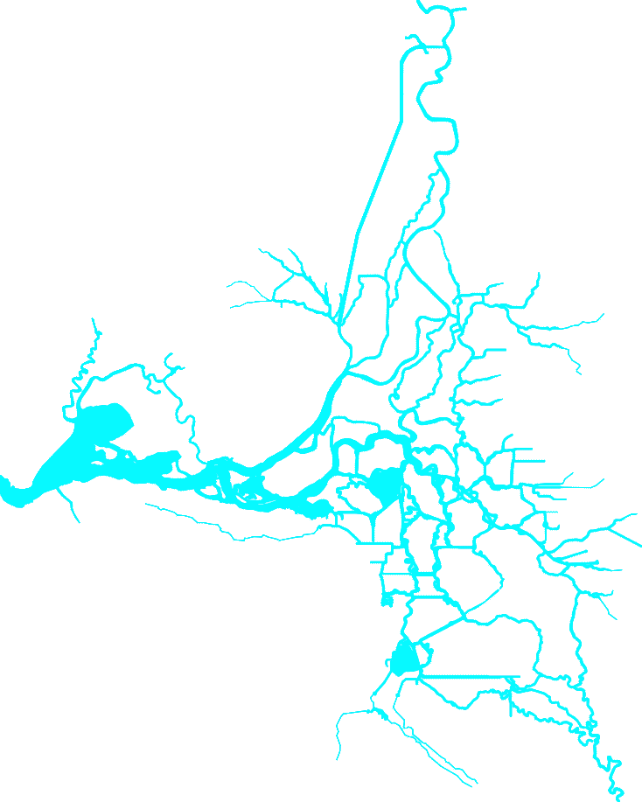 

a)

b)

c)

 

f) Other

draw your own

e)

d)

What is the basis for your answer above?

❑ Field experience in the Delta

❑ Field experience in another system __________________________________

❑ Educated guess

❑ Gut feeling

❑ Wild guess

❑ Doodling fun

❑ Other___________________________________________________________